FILES :

In C++, files are mainly dealt by using three classes fstream, ifstream, ofstream available in fstream headerfile.   
**ofstream:** Stream class to write on files   
**ifstream:** Stream class to read from files   
**fstream:** Stream class to both read and write from/to files.

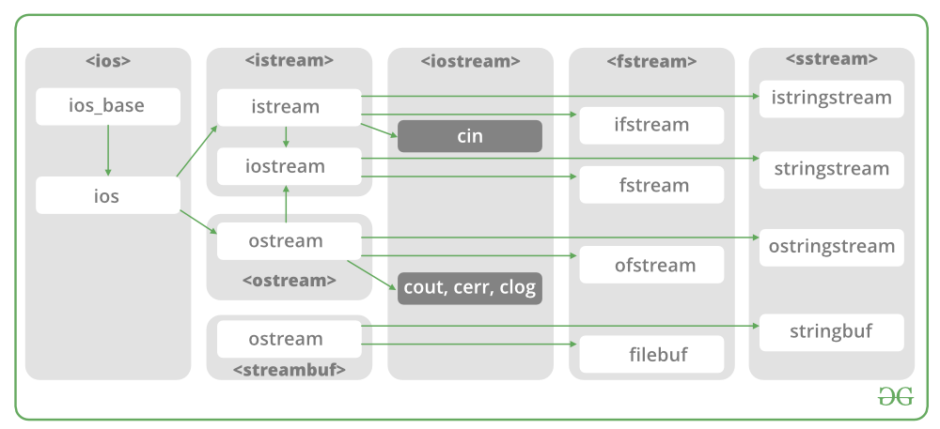

Now the first step to open the particular file for read or write operation. We can open file by   
1. passing file name in constructor at the time of object creation   
2. using the open method

**For e.g.**

***Open File by using constructor****ifstream (const char* filename, ios_base::openmode mode = ios_base::in);   
ifstream fin(filename, openmode) by default openmode = ios::in   
ifstream fin(“filename”)*

**Default Open Modes :**

|  |  |  |  |  |  |  |  |  |  |  |  |  |  |  |  |  |  |  |  |  |  |  |  |  |  |  |  |  |  |  |  |
| --- | --- | --- | --- | --- | --- | --- | --- | --- | --- | --- | --- | --- | --- | --- | --- | --- | --- | --- | --- | --- | --- | --- | --- | --- | --- | --- | --- | --- | --- | --- | --- |
| |  |  | | --- | --- | | ifstream | ios::in | | ofstream | ios::out | | fstream | ios::in | ios::out |  | Member Constant | Stands For | Access | | --- | --- | --- | | in * | input | File open for reading: the internal stream buffer supports input operations. | | out | output | File open for writing: the internal stream buffer supports output operations. | | binary | binary | Operations are performed in binary mode rather than text. | | ate | at end | The output position starts at the end of the file. | | app | append | All output operations happen at the end of the file, appending to its existing contents. | | trunc | truncate | Any contents that existed in the file before it is open are discarded. | | /* File Handling with C++ using ifstream & ofstream class object*/  /* To write the Content in File*/  /* Then to read the content of file*/  #include <iostream>   #include <fstream>    using namespace std;  int main()  {      ofstream fout;        string line;     //fout.open("sample.txt",ios::app)      fout.open("sample.txt");        // Execute a loop If file successfully opened      while (fout) {            // Read a Line from standard input          getline(cin, line);            // Press -1 to exit          if (line == "-1")              break;            // Write line in file          fout << line << endl;      }        // Close the File      fout.close();        // Creation of ifstream class object to read the file      ifstream fin;        // by default open mode = ios::in mode      fin.open("sample.txt");        // Execute a loop until EOF (End of File)      while (fin) {            // Read a Line from File          getline(fin, line);            // Print line in Console          cout << line << endl;      }        // Close the file      fin.close();        return 0;  } |  |  | |  |